Universidad Interamericana de Fajardo, Puerto Rico
Computer Science
COMP 2900 Data Structures
Prof. Milagros Donato Cintrón
Zaniel Cruz Castro y Danny Quiñones Carrasquillo

Final Project: Task Manager
Breakdown and Documentation

TaskManager.java

The TaskManager class serves as a central controller for managing the lifecycle of Task objects. By combining linear lists, key-value maps, and specialized data structures (Stacks and Queues), it achieves a balance between fast lookups, ordered tracking, and state restoration (undo).
Data Structures & Architecture
The class uses four distinct data structures, each serving a unique architectural purpose:
Data Structure | Variable Name | Purpose | Performance Benefit
ArrayList<Task> | taskList | Maintains a master chronological list of all tasks. | $O(1)$ continuous insertions and positional indexing.
HashMap<Integer, Task> | taskMap | Maps unique Task IDs to Task objects for rapid querying. | Reduces search time from $O(n)$ to $O(1)$ average time complexity.
Stack<Task> | undoStack | Tracks completed tasks using Last-In, First-Out (LIFO) logic to support an undo feature. | $O(1)$ push and pop operations for tracking the most recent action.
LinkedList<Task> (Queue) | pendingQueue | Tracks tasks in a First-In, First-Out (FIFO) pipeline for sequential processing. | $O(1)$ insertion at the tail and removal from the head.

API Documentation
Class Definition
- Package: datastructureproject
- Access Modifier: public
Methods
void addTask(Task t)
Adds a new task to the manager and registers it across the tracking ecosystems.
- Parameters: t - The Task object to be managed.
- Behavior:
  - Appends the task to the master taskList.
  - Binds the task's unique ID to the object in taskMap.
  - Enqueues the task into pendingQueue for eventual processing.
void completeTask(int id)
Marks a specific task as completed based on its unique identifier.
- Parameters: id - The unique integer ID of the task.
- Behavior:
  - Performs an $O(1)$ lookup in the taskMap.
  - If found, updates the task's internal status enum to Task.Status.COMPLETED.
  - Pushes the modified task onto the undoStack to allow the action to be reverted.
void undo()
Reverts the last completion action, restoring the most recently completed task back to a pending state.
- Behavior:
  - Checks if there are actions to revert using !undoStack.isEmpty().
  - Pops the top task off the undoStack (LIFO order).
  - Resets its status enum to Task.Status.PENDING.
List<Task> getTasks()
Retrieves the master list of all tasks.
- Returns: A List<Task> containing all added tasks in chronological order.

Code Quality Observations & Recommendations
While the current implementation is clean and functional, here are a few structural enhancements you might want to consider to prevent edge cases:
- Incomplete Queue Cleanup: In completeTask(int id), the task status is updated, but the task is not removed from the pendingQueue. If you intent to use pendingQueue as a strict "to-do pipeline," you should remove tasks from it when they are completed.
- Encapsulation Risk: getTasks() returns the direct reference to taskList. External classes can modify, clear, or corrupt this list without the TaskManager knowing. Consider returning an unmodifiable view:
Java
return Collections.unmodifiableList(taskList);
- Thread Safety: This class uses standard collections (ArrayList, HashMap) which are not thread-safe. If multiple threads access this manager simultaneously, you may encounter ConcurrentModificationException errors.

Photo of the code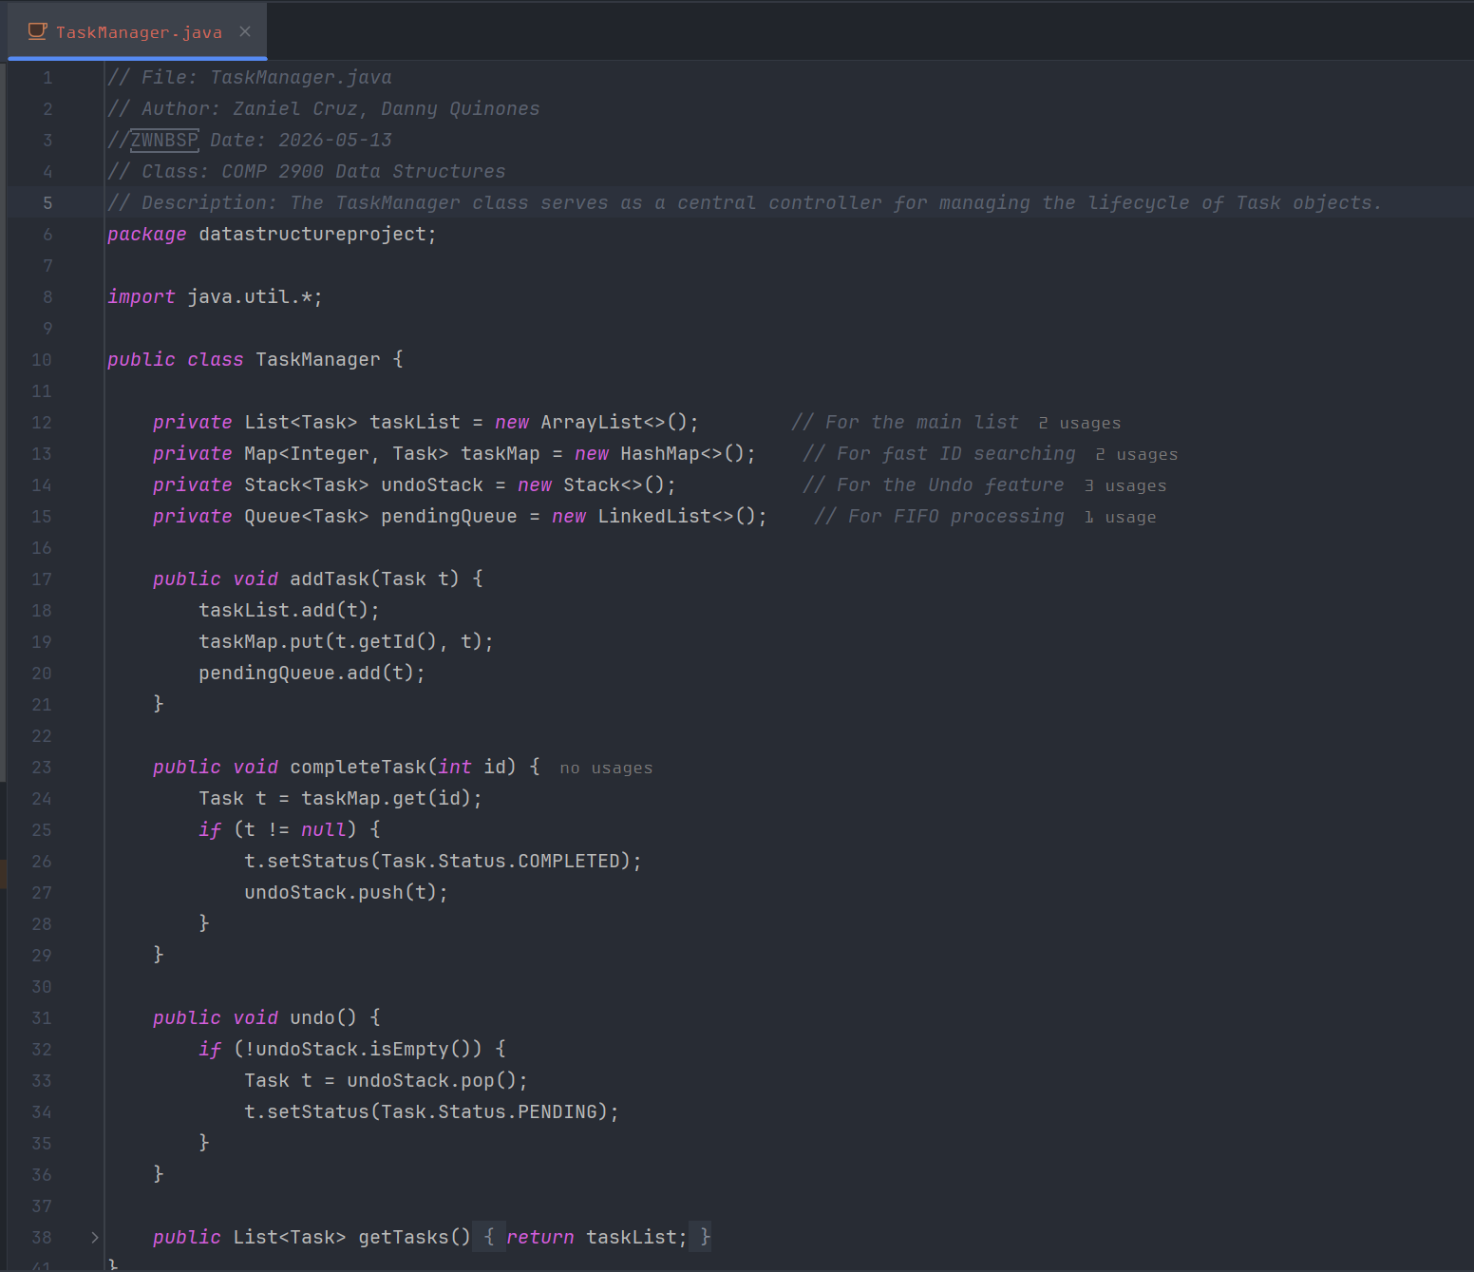

Task.java

The Task class encapsulates the attributes of a single task entity. It utilizes strongly typed inner Java enum structures to enforce valid states for both a task's severity (Priority) and its lifecycle stage (Status). This prevents invalid data (like typos in strings) from breaking the business logic of your TaskManager.
State Machine Lifecycle
When a Task is instantiated, it follows a strict state progression dictated by its methods and fields:
[Instantiation]
│
▼
Status: PENDING ───( Via TaskManager.completeTask() )───► Status: COMPLETED
▲ │
└─────────────────( Via TaskManager.undo() )────────────────┘

API Documentation
Class Definition
- Package: datastructureproject
- Access Modifier: public
Nested Types (Enums)
Task.Priority
Represents the urgency of the task.
- Constants: HIGH, MEDIUM, LOW
Task.Status
Represents the current lifecycle state of the task.
- Constants: PENDING, COMPLETED

Constructor
public Task(int id, String title, Priority priority)
Initializes a new Task instance with a default status.
- Parameters:
  - id: A unique integer identifier for the task.
  - title: A short string description or name of the task.
  - priority: A Task.Priority enum value representing urgency.
- Behavior: Sets the provided identifier, title, and priority, and explicitly sets the initial status to Status.PENDING.

Methods
Getters (Accessors)
- public int getId(): Returns the task's unique integer ID.
- public String getTitle(): Returns the task's text description.
- public Priority getPriority(): Returns the assigned Task.Priority enum.
- public Status getStatus(): Returns the current Task.Status enum.
Setters (Mutators)
- public void setStatus(Status status): Updates the current status of the task. This is the only mutable field in the class, allowing managers (like TaskManager) to shift tasks between PENDING and COMPLETED.

Overridden Methods
public String toString()
Generates a uniformly formatted string representation of the task, optimized for console/terminal display layouts.
- Format Mechanism: It uses String.format() with fixed-width specifiers (%-15s and %-6s) to ensure columns align beautifully when multiple tasks are printed in a terminal list.
- Output Example:
Plaintext
[101] Fix Bug 404 | Priority: HIGH | Status: PENDING
[102] Code Review | Priority: MEDIUM | Status: COMPLETED

Code Quality Observations & Recommendations
- Immutability of Core Fields: Your design correctly leaves out setter methods for id, title, and priority. Making them unmodifiable after creation is an excellent object-oriented design choice that prevents side effects elsewhere in your application. To make this explicit and compile-time safe, you could declare them as final:
Java
private final int id;
private final String title;
private final Priority priority;
- Hash/Equality Contract Missing: Because this Task class is being stored inside a HashMap (as seen in your TaskManager), it is highly recommended to override the equals(Object o) and hashCode() methods using the id field. Without overriding these, Java uses memory addresses for map lookups, which could cause unexpected behaviors if you ever work with serialized or duplicated task objects.

Photo of the code:
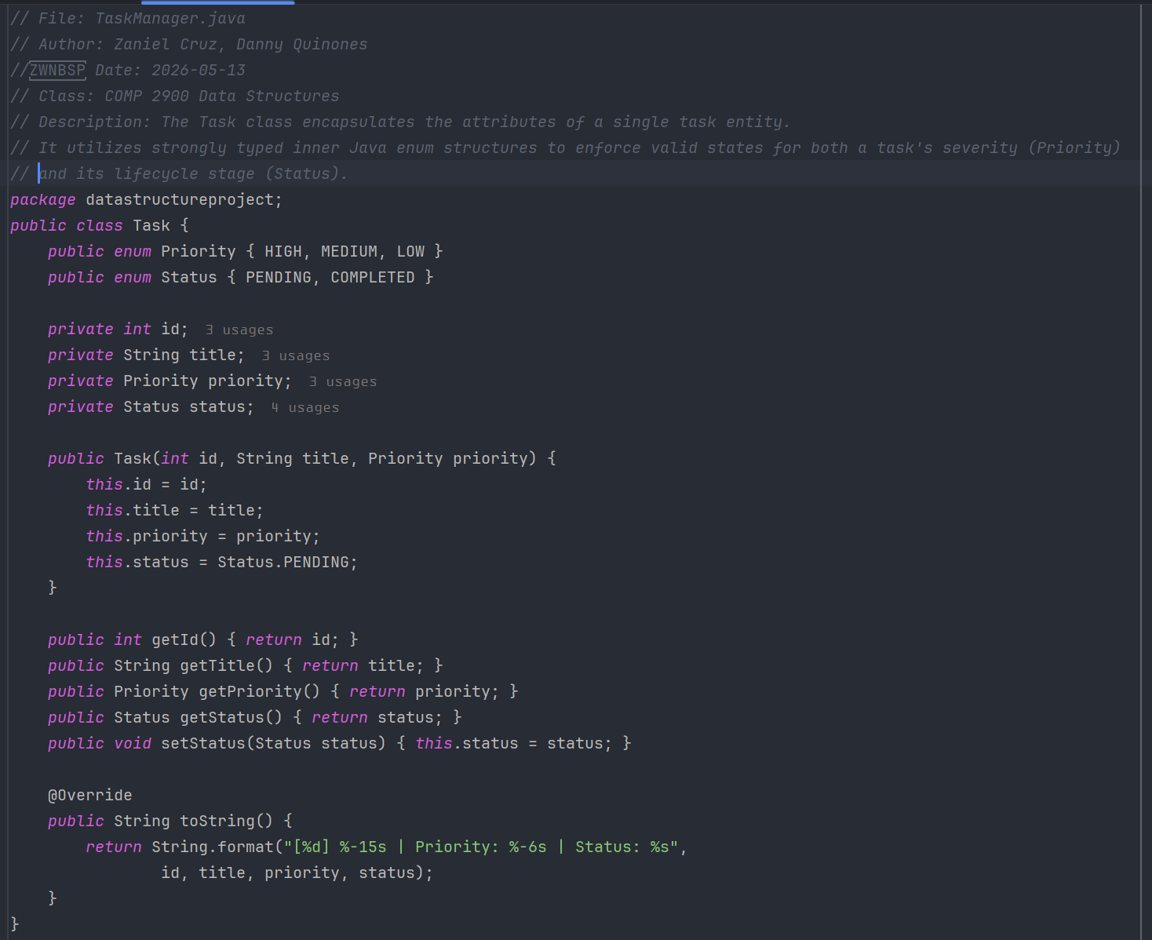

MainApp.java

The MainApp class constructs and controls a Graphical User Interface (GUI) built on Java Swing components. It adopts an event-driven architecture, listening for user interactions (button clicks) and updating the data model (TaskManager) and visual layout (DefaultListModel) concurrently.
The application utilizes a custom dark-mode aesthetic with a "Cyberpunk" inspired palette to elevate the standard, archaic look of default Swing windows.
Layout Architecture
The user interface follows a predictable layout scheme mapped out using standard Swing layouts:
- BorderLayout.NORTH: House the title header label (lblTitle).
- BorderLayout.CENTER: Houses the main interactive viewport scrolling task lists (JScrollPane).
- BorderLayout.SOUTH: Implements a stacked layout (a 2x1 grid layout nesting two distinct action rows for data inputs and execution triggers).

API Documentation
Class Definition
- Package: datastructureproject
- Access Modifier: public
State & Configuration Constants
Core Logic Bridges
- private TaskManager manager: The operational brain holding your maps, lists, stacks, and queues.
- private DefaultListModel<Task> listModel: The specialized container that feeds task changes into the graphical UI.
- private JList<Task> taskListUI: The actual component that renders the list model data items on screen.
Styling Palette (Thematic)
- CYBER_BLUE: Used as accent colors for critical interactions like additions and highlight bounding borders.
- DEEP_NAVY: Acts as the dominant canvas background color.
- NEON_YELLOW: Highlights high-impact items (the main title and task completion button).

UI Lifecycle & Methods
public MainApp() (Constructor)
Assembles, decorates, and structures the graphical application window.
- Component Pipeline:
  - Configures the parent frame wrapper (JFrame) properties (size, close behaviors, layout boundaries).
  - Generates labels and styles the visual logging space using code format configurations defined in your Task.toString() implementation.
  - Wireframes the sub-panels, injecting inline structural input constraints (like specific text-field bounding widths and priority choice dropdown boxes).
  - Appends structural lambda-based functional behavior hooks to action buttons (ADD TASK, COMPLETE TASK, UNDO).
private void refresh()
Synchronizes the visible UI display with the source data inside TaskManager.
- Execution Strategy: Empties the current view template state via listModel.clear(), polls the current linear execution profile lists back out of your backend manager instance (manager.getTasks()), and streams each element sequentially into the active window frame rendering queue.
private void styleButton(JButton b, Color bg, Color fg)
Helper tool to standardise look-and-feel rules across buttons, configuring backgrounds, typography sizing, and suppressing old default operational text focus boxes.
private JLabel createLabel(String text)
Quick utility constructor to stamp out standard white typography labels cleanly.

User Interaction Mechanics
Event Binding Pipelines
1. Task Injection Pipeline (btnAdd)
- Behavior: Reads string value text from inputs and parses input values to evaluate identifiers.
- Error Prevention: Leverages a try-catch safety block wrapper. If users attempt to create invalid structural IDs (e.g., entering letters into the number block), a graceful modal error pop-up window emerges (JOptionPane.showMessageDialog), ensuring the core JVM loop doesn't crash on runtime exceptions.
2. Complete Phase Progression Pipeline (btnComplete)
- Behavior: Queries the interactive user cursor selection point directly out of the UI container (taskListUI.getSelectedValue()). If an item is active, it forwards the internal item index ID straight down into the data map ecosystem to toggle its operational enum statuses.
3. State Reversion Execution (btnUndo)
- Behavior: Directly requests the underlying manager collection infrastructure to discard the last element popped from the undo history stack cache, executing a global UI state canvas refresh immediately after.

Code Quality Observations & Recommendations
- Hardcoded UI Font Risks: Using fixed font identifiers like "Segoe UI" or "Monospaced" can occasionally lead to formatting discrepancies on non-Windows target platforms (such as Linux or macOS distributions) if those font files are missing. A safer default alternative is to rely on logical environment constants like Font.SANS_SERIF or Font.MONOSPACED.
- Selection State Validation: If a user clicks the COMPLETE TASK button while no task is highlighted in the list UI, the application safely skips the execution block without throwing errors. However, adding a warning dialog or disabling the button dynamically until a row is chosen would improve the overall user experience (UX).
Photos of the code:
